FERRET User Guide

# Introduction

The FERRET application allows the user to display an MR signal/time curve for a region of interest and fit a model to that curve. The values of the model parameters that achieve this fit are displayed on the left-hand side of the GUI. It is also possible for the user to manually adjust the values of these model parameters and observe how the shape of the model curve changes.

MR signal values are input to FERRET as Comma Separated Values (CSV) at discrete time points in a CSV file. The first column in this CSV file must contain time values in seconds. The remaining columns of data must contain MR signal data for individual organs at the time points in the time column. There must be at least 2 columns of MR signal data but there is no upper limit on the number of columns of MR signal data.

FERRET has been developed using the Python programming language. It is possible for anyone with a knowledge of the Python and XML to add their own models to FERRET. This is described in the FERRET Developer Guide.

The diagram below shows a screenshot of the FERRET application with a plot of the MR signal pertaining to the concentration of a tracer compound in the liver (blue solid curve). The High Flow Single Inlet – Two Compartment Filtration and 3DSPGR model has been fitted to this curve (green dotted line). In the middle of the left-hand side of the screen, the three model parameters and their resultant values are displayed. 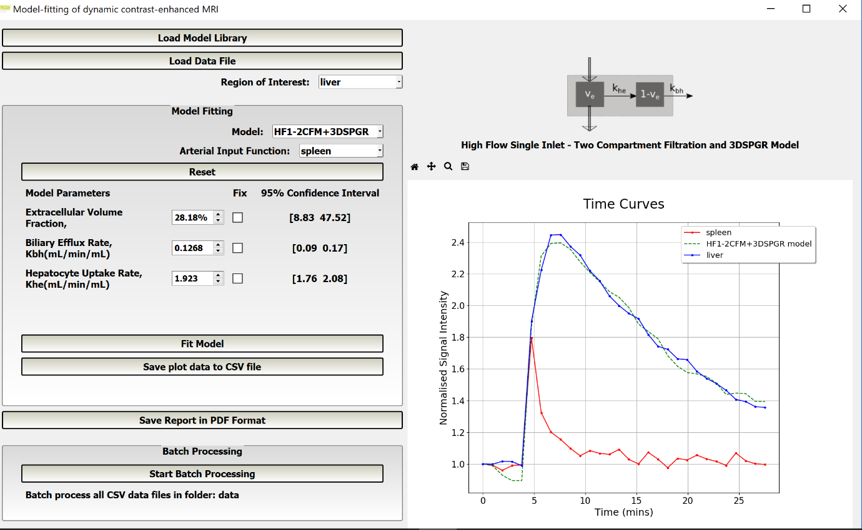

# Using the FERRET application

In this section, the steps required to perform an analysis with FERRET are described.

1. If you are running FERRET from source code, the start-up form is **FERRET.py**. If you are running the compiled version of FERRET, double-click the file **FERRET.exe**. FERRET launches with the following screen,

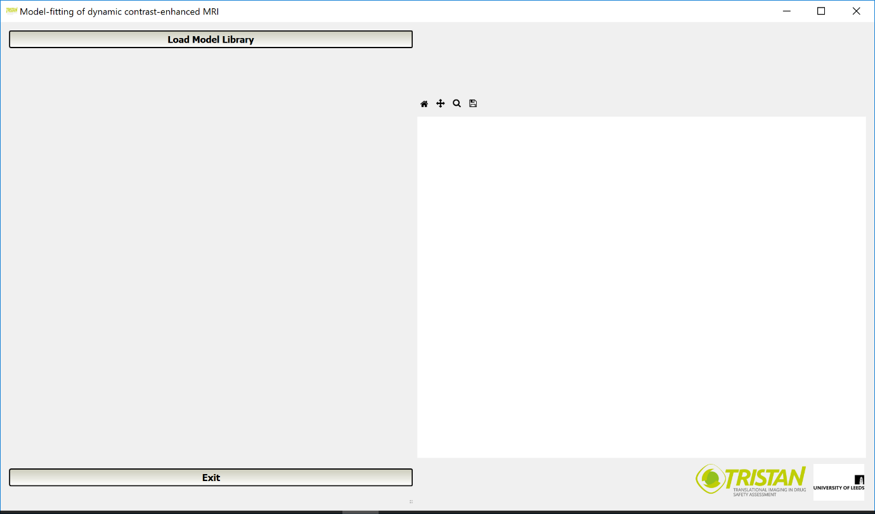

1. Clicking the **Load Model Library** button, displays the contents of the **config** folder and allows the user to select and load a model library XML file into the FERRET application. A model library XML file describes a list of models in XML format. The list of models in the **Model:** dropdown list is created from information in the selected model library XML file. When a model is selected from this dropdown list, details of its parameters such as name, units and default value are retrieved from the model library XML file. Select a file and click **Open**.

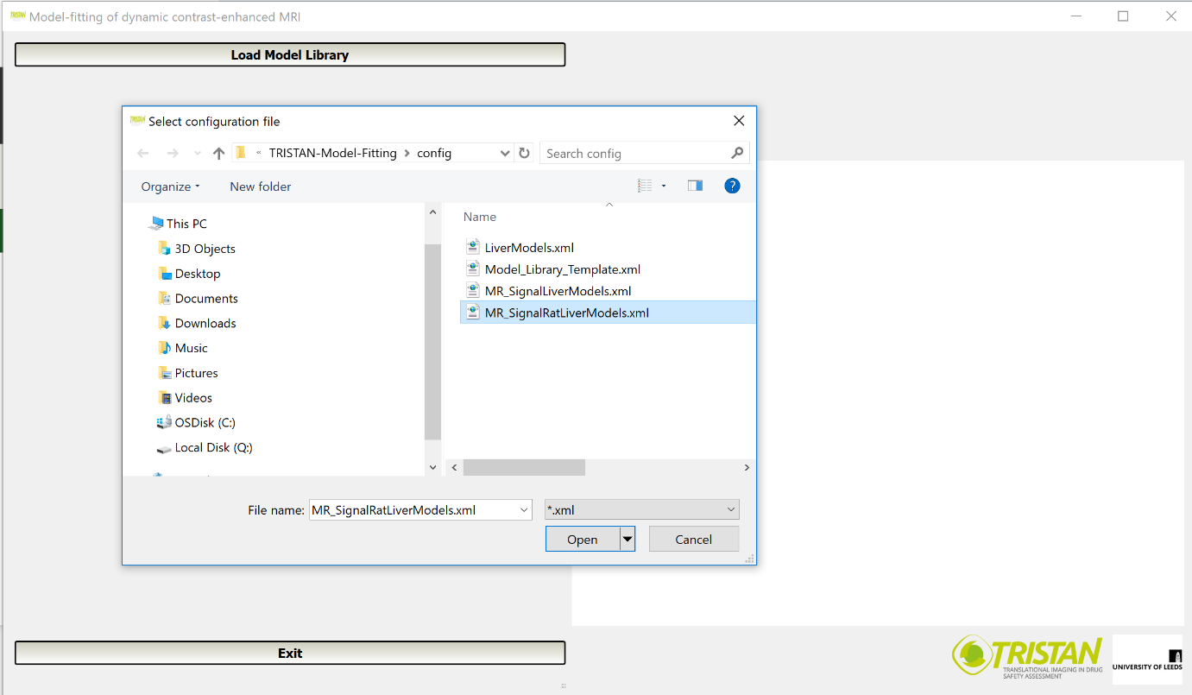

1. The **Load Data File** button will now be displayed. Clicking the **Load Data File** button, displays the contents of the **data** folder and allows the user to select and load a CSV file of time and MR signal data for several organs. The lists of organs in the **Region of Interest**, **Arterial Input Function** and **Venous Input Function** (if displayed) dropdown lists are formed from the column headers in the CSV data file. Select a file and click **Open**.

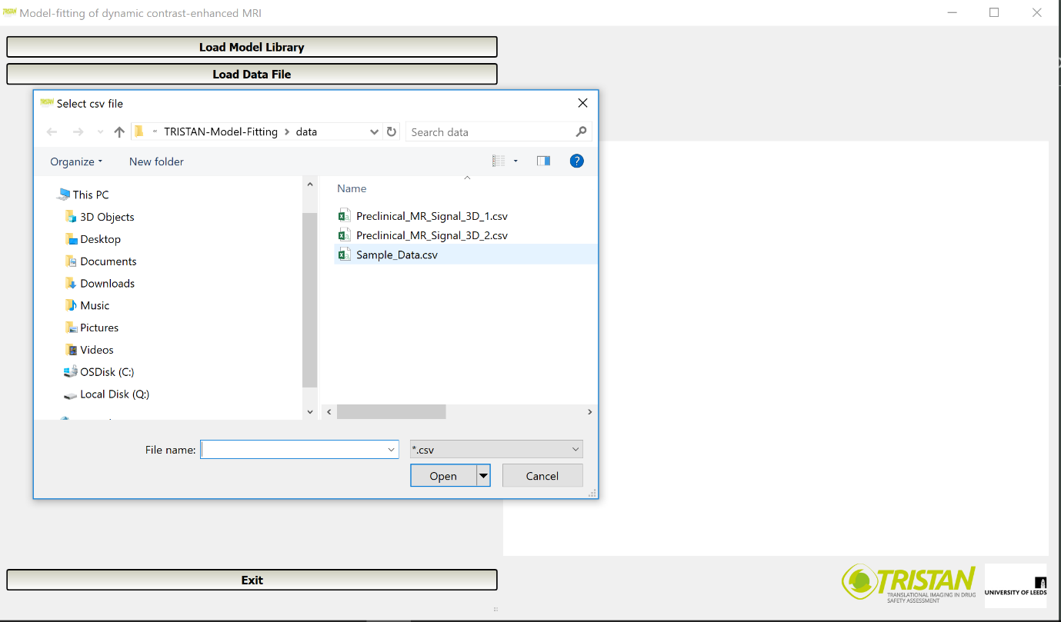

1. The **Region of Interest** (ROI) dropdown list will now be displayed. Select an organ from the list.

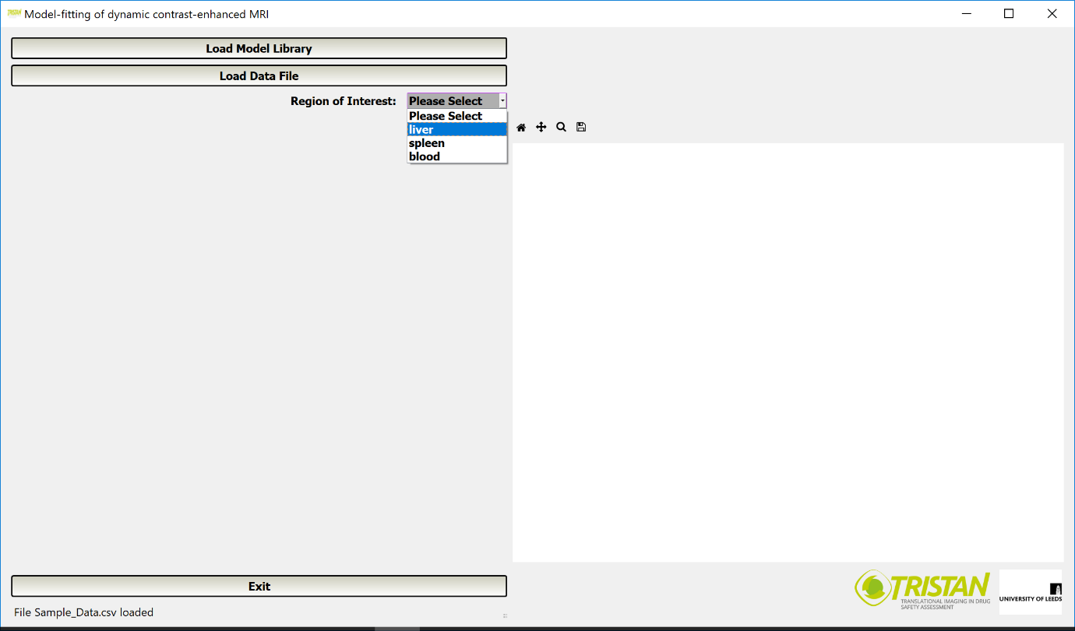

1. The normalised signal intensity/time curve of the selected ROI will be displayed on the right-hand side of the application screen and a list of models will be displayed in a dropdown list on the left-hand side of the screen. Select a model.

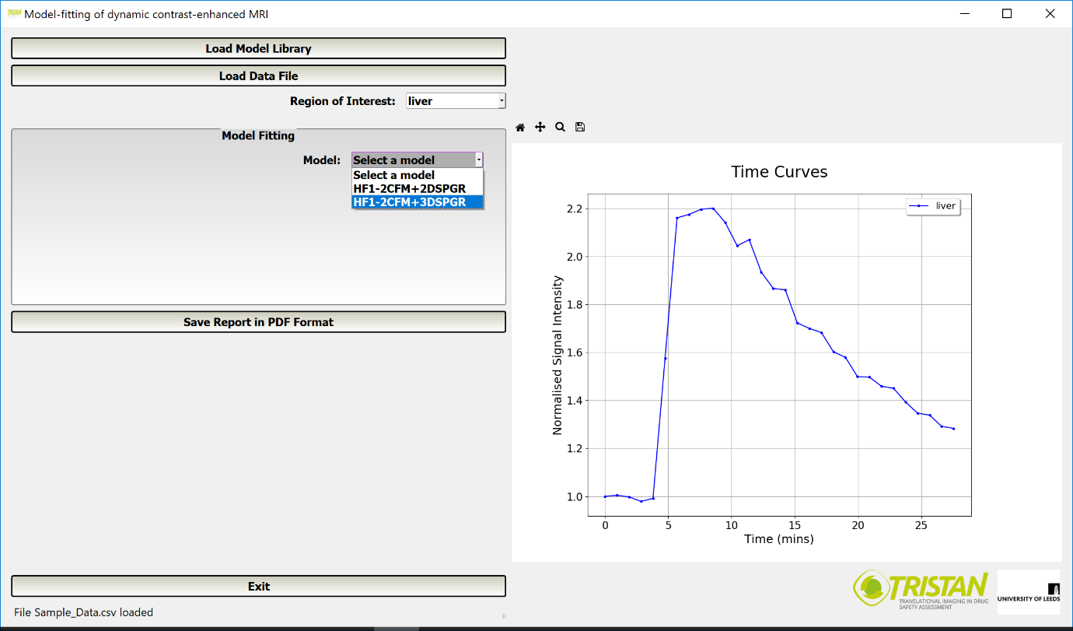

1. If a single inlet model is selected then a dropdown list of **Arterial Input Functions** (AIF) is displayed. If a dual inlet model is selected then dropdown lists of **Arterial Input Functions** and **Venous Input Functions** are displayed. Additionally, parameters for the selected model are displayed with their default values. Select an AIF.

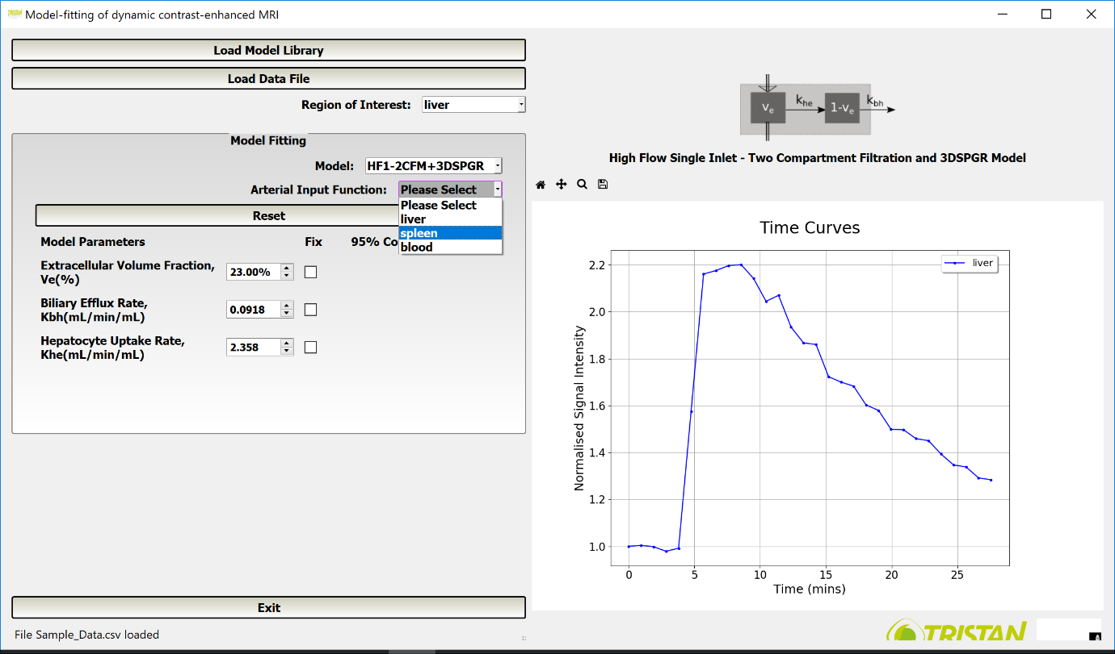

1. When an AIF is selected, its normalised signal intensity/time curve is also displayed on the right-hand side of the application screen. Additionally, on the same axes, the normalised signal intensity/curve predicted by the selected model using the default parameter values is displayed.

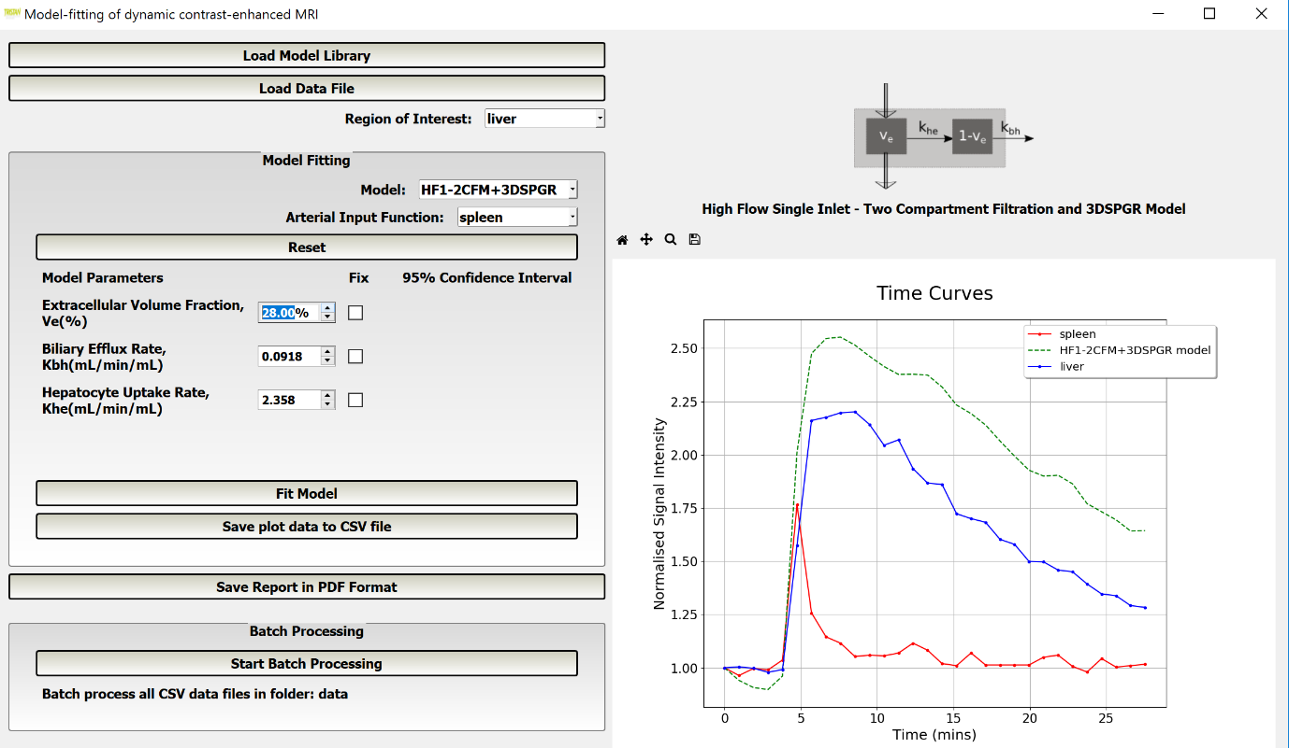

1. It is possible to investigate the influence of each model parameter on the shape of the model curve by changing its value. Model parameter values are displayed in a spin box, so a new value can be typed into the spin box or the value of the parameter may be incremented or decremented using the upwards and downwards arrows on the right-hand side of the spin box.

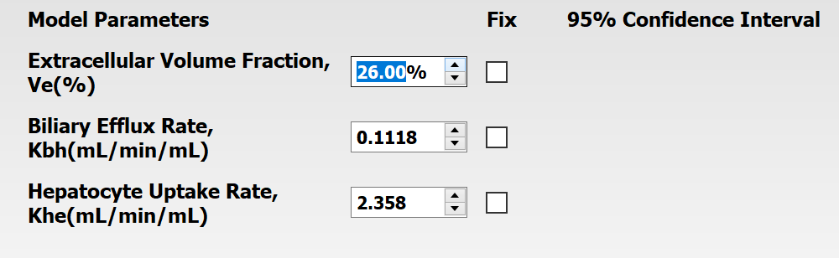

1. Model parameter values may be reset to their default values by clicking the **Reset** button.

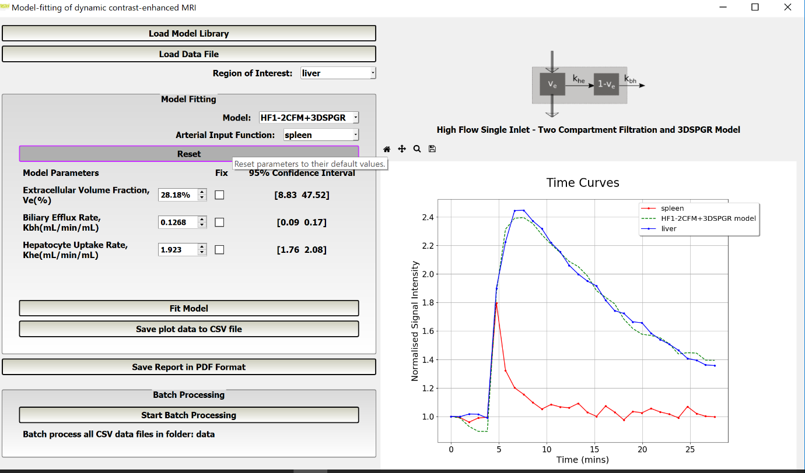

1. The model may be fitted to the ROI curve by clicking the **Fit Model** button. The values of the model parameters in their spin boxes are used as their initial values in model fitting. The resultant optimised parameter values are then displayed in the corresponding spin box. For each optimised parameter value, its 95% confidence interval is also displayed.

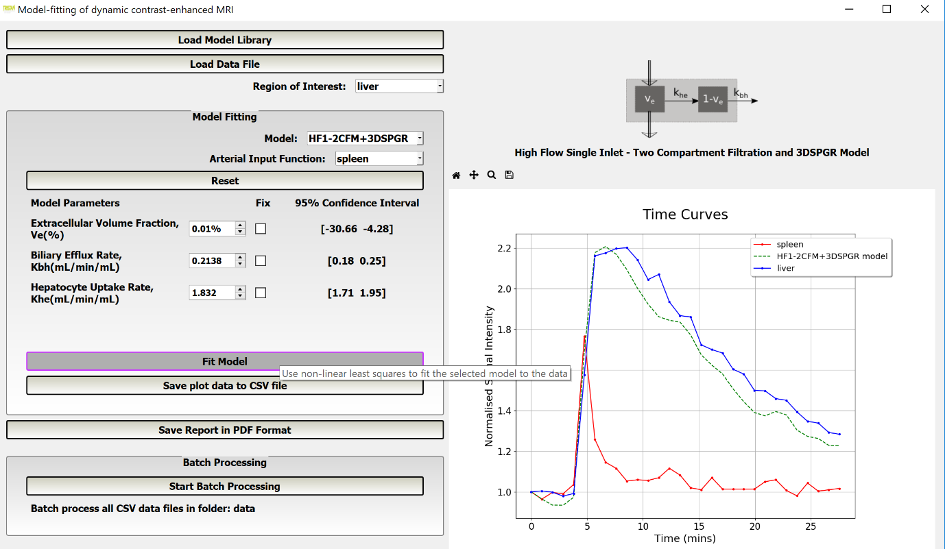

1. By checking the Fix checkbox next to a parameter, its value may be fixed during curve fitting.

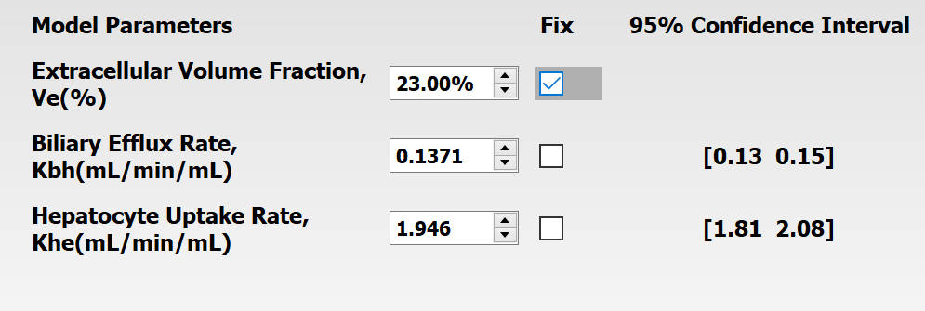

1. Clicking the **Save plot data to CSV file** button saves all the data currently plotted on the right-hand side of the GUI to a CSV file, with a headed column of data for each curve on the plot. A save file dialog is opened for the user to select a name and location for this file. The data in this CSV file may be used to recreate the plot at a later date.

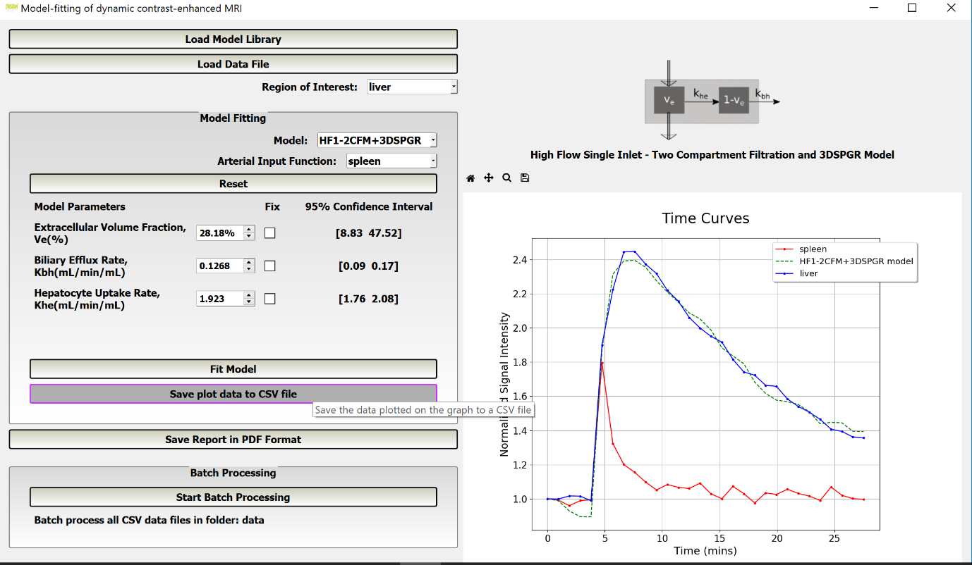

Typically, the first few lines of this CSV file may look like,

Time (min),liver,spleen,HF1-2CFM+3DSPGR model

0.0,1.0,1.0,1.0

0.95,0.9981971405811079,0.991728813559322,0.9886985024168173

1.9,1.0162676617332607,0.9597288135593219,0.9288269976888837

2.85,1.015051779799589,0.9886779661016949,0.8950270591306416

3.8,0.9883023772588151,0.9938305084745763,0.8945588602159229

1. Clicking the **Save Report in PDF Format** button opens a save file dialog that allows the user to select the name and location of a PDF report that contains a table of the model parameters, their values, and if curve fitting has just been performed, their 95% confidence interval. Additionally, this report contains a copy of the plot of normalised signal intensity/time curves.

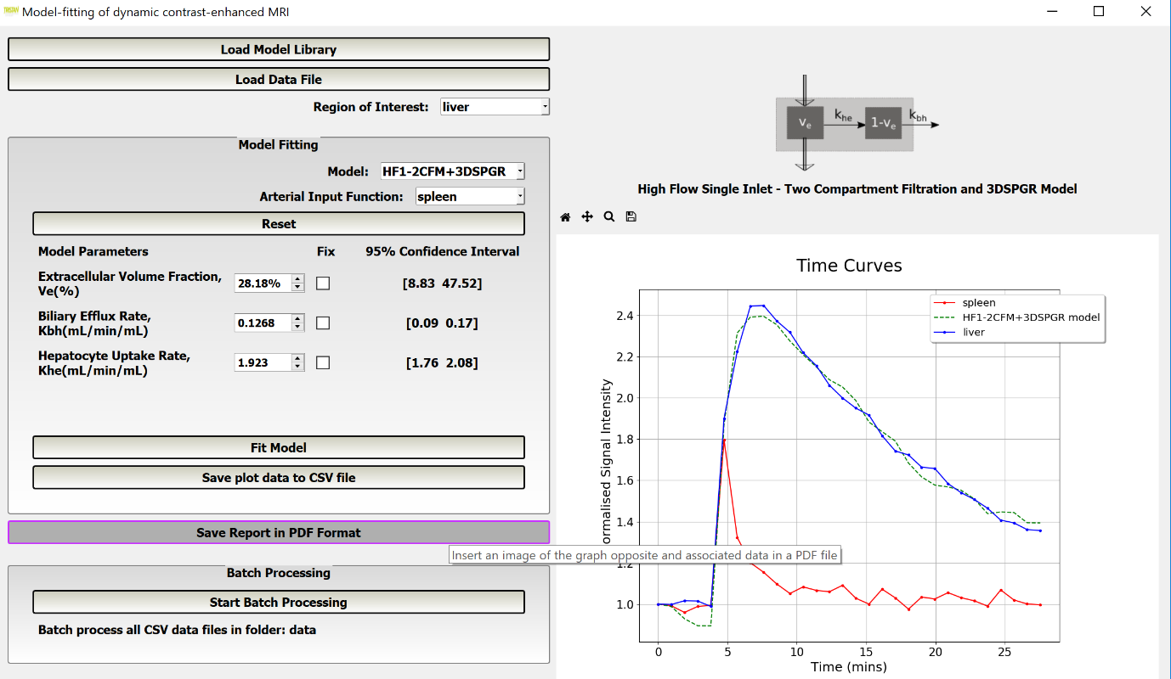

Typically, a PDF report has the following appearance,

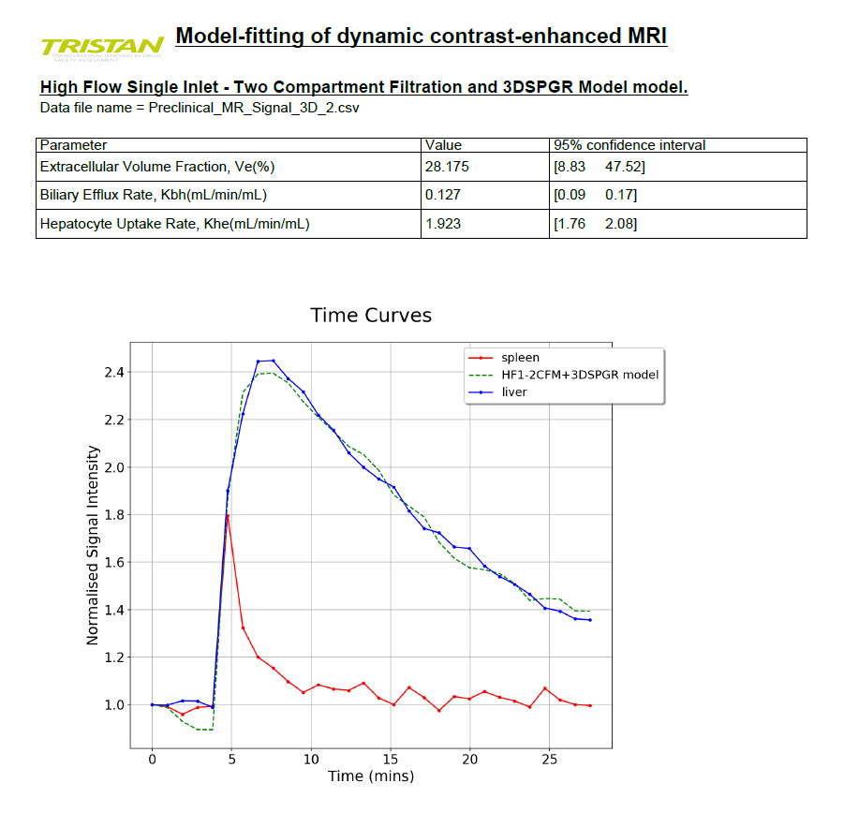

1. Clicking the **Start Batch Processing** button will automatically fit the model selected in step 5 to MR signal/time data in 2 or more files in the same folder as the data file selected in step 3.

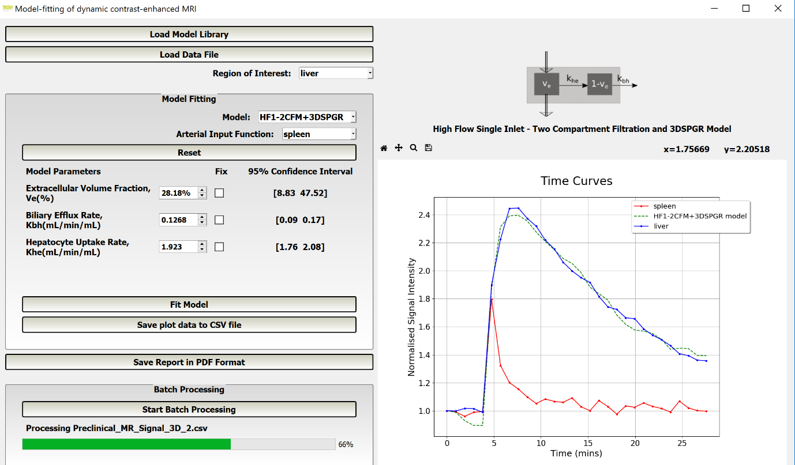

During batch processing, for each data file, a PDF report containing the MR signal/time curve plot and a table of the optimum parameter values and their 95% confidence limits is created as in step 13 and stored in a folder called PDFReports.

Likewise, for each data file, the time/MR signal data in the plot after curve fitting is saved in csv format in a file as in step 12 and stored in a folder called CSVPlotDataFiles.

Both PDFReports and CSVPlotDataFiles are created automatically in the same folder as the data files being batch processed.

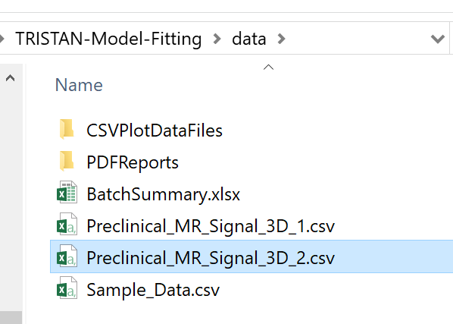

To undertake batch processing:

1. Put all the data files you wish to batch process in the same folder. Note, all csv files in this folder will be included in the batch processing. However, files will be skipped over which do not meet the following criteria: the first column contains time data followed by at least 2 columns of MR signal data and each column must have a header.
2. Load one of these files.
3. Select the region of ROI for the whole batch.
4. Select the model for the whole batch.
5. Select the AIF and VIF (if appropriate) for the whole batch. After clicking the **Start Batch Processing** button, if the model parameter values have been changed from their defaults, you will be asked if you wish to use the new or the default values as initial values.

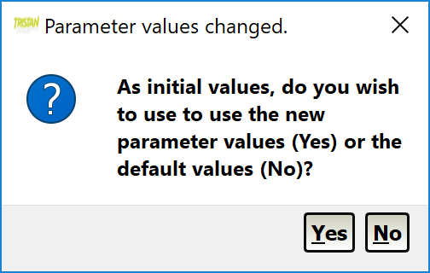

1. As each data file is processed, its name, the optimum parameter values and their 95% confidence limits are recorded in a batch summary Excel spreadsheet. Additionally, the names of any files that fail the validation tests are recorded in the batch summary Excel spreadsheet together with the reasons for their failure. Next you will be asked to give the name and location of this batch summary Excel spreadsheet or accept the defaults.

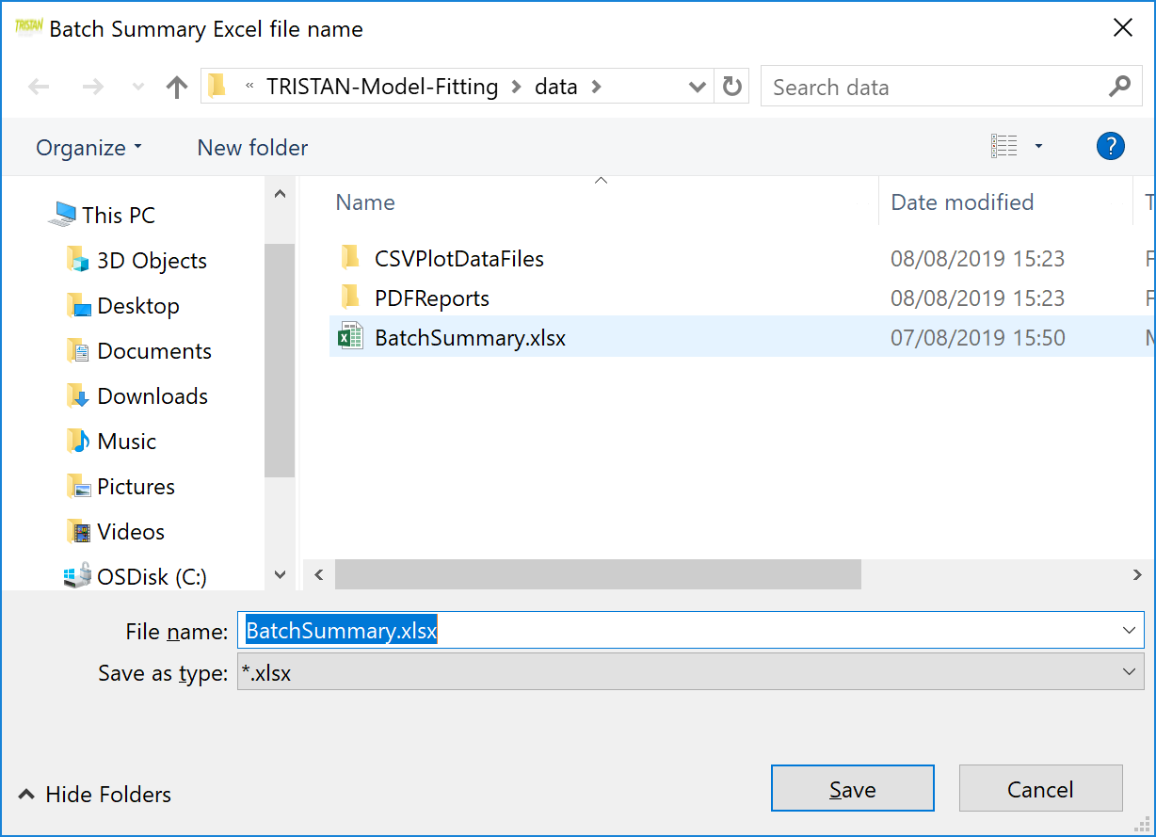

1. The progress bar will show the progress of batch processing and indicate when it is complete.